User’s Guide

Brand: English Teacher
Model: Ashley Hutchinson, iOS 3.1

At a Glance
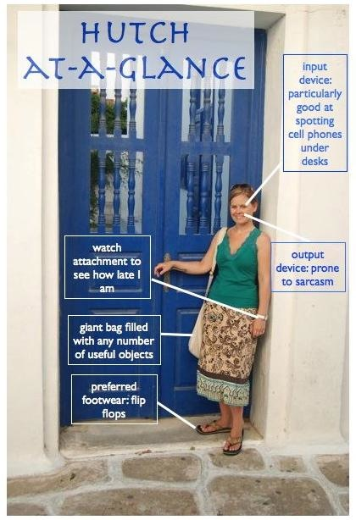

Product Guide

Congratulations on your new English teacher, Ashley Hutchinson 3.1, commonly referred to as “Hutch” or “Mrs. Hutchinson.” Your new English teacher comes with functions including but not limited to the following:
-Teaching you about rhetoric
-Encouraging higher order thinking skills
-Facilitating vocabulary development
-Critiquing and helping you improve your writing
-Providing the occasional humorous story

Getting Started

Before you access Mrs. Hutchinson for the first time, you will need to make sure that you have completed your summer reading journals (if applicable). Your Mrs. Hutchinson will respond most favorable to users who begin school prepared to learn, discuss, and write.

Accessibility

Mrs. Hutchinson has numerous access opportunities throughout the day. She can be contacted in person during the school day in either her classroom, 320, or her office, 312C. Mrs. Hutchinson is, however, not a stationary device and has a tendency to veer unexpectedly toward the 600 hall, where the Foods classrooms are located. Technical support is looking into this glitch. After school, she can be reached via e-mail at hutchia@pitt.k12.nc.us. Mrs. Hutchinson typically responds to e-mail immediately because she is a compulsive e-mail checker, so if she doesn’t get back to you within 24 hours, your e-mail may have gone to her quarantine folder. You may also follow Mrs. Hutchinson on Twitter @gothutched. She does not tweet often, but she does receive notifications and will respond and/or retweet.

Settings

Mrs. Hutchinson has three primary settings: teacher, parent, and regular person.

Setting 1: Teacher

You will interface with Mrs. Hutchinson most often in teacher mode, so this will be her default setting during the hours of 8:10-3:45. In teacher mode, Mrs. Hutchinson is responsible for AP English Language and Composition, Journalism, Contemporary Literature, English I, etc. Mrs. Hutchinson attempts to set clear expectations for each class, assignment, and student, but if you have a question about those expectations, she is happy to answer that question.

Setting 2: Parent

Mrs. Hutchinson has two small children, Addie Grace (10 months as of this writing) and Liam, (2 years as of this writing), and this mode will override all other modes as needed. In the Parent Setting, Mrs. Hutchinson has the ability to go from calm to crazy in seconds when her children are confronted with any sort of danger or disparaging remark. However, patience is one of the most sought-after features in this setting, and in fact, the addition of the Parent Setting in 2011 has given the most recent operating systems a significant increase in patience in other settings as well.

Setting 3: Regular Person

The regular person setting allows this device to recharge, so it is very important that Mrs. Hutchinson gets the opportunity each day to spend some time in regular person setting. In this setting, she can read, watch TV, go shopping, spend time with her husband, or any other type of leisure activity.

Warnings

This device may…
- be prone to sarcasm
- get so focused on whatever she’s reading that she doesn’t hear you ask to go to the bathroom/go talk to Ms. Upton/for a million dollars
- say that she will cut somebody for any number of perceived offenses (these are empty threats; she will not physically harm anyone, and verbal evisceration only happens occasionally)
- get frustrated, but this is only a temporary state; device does not hold grudges
- be very blunt, but the upside is that you know she isn’t sugarcoating anything
- badger you about joining the staff of the school newspaper (take this as a major compliment)

Troubleshooting

Problem | Solution
You are not getting the grade you want in Mrs. Hutchinson’s class. | Remember that the purpose of school is to learn, not to get a certain grade. If you truly concern yourself with learning in Mrs. Hutchinson’s class, better grades are more likely to follow.
You desperately want to know your grade on a test/quiz/paper. | Wait one week. Do not ask Mrs. Hutchinson incessantly when you will be getting the assignment back. After one week, you may ask, but do try to remember that Mrs. Hutchinson has about 90 students, so if she assigns a two page paper, she has 180 pages to read and grade.
You forgot when Mrs. Hutchinson said an assignment was due. | Check the board. Check the website. If it’s not there, check with Mrs. Hutchinson.
You forgot to follow Mrs. Hutchinson’s instructions | Talk to Mrs. Hutchinson or send her an e-mail letting her know what happened. She can be very understanding as long as you communicate with her.

Tips to Maintain Optimal Performance:
Fuel with Starbucks, preferably of the pumpkin spice variety for fall.
Be real and put thought into your writing.
Communicate openly and frequently with Mrs. Hutchinson.
Tell this device about good books you have recently read. She loves to talk about books.

