Directions: The following question requires you to construct a coherent essay that integrates your interpretation of Documents A-J and your knowledge of the period referred to in the question. High scores will be earned only by essays that both city key pieces of evidence from the documents and draw on outside knowledge of the period.

Analyze the responses of Franklin D. Roosevelt’s administration to the problem of the Great Depression. How effective were these responses? How did they change the role of the federal government?

Document A

Source: Meridel Lesueur, New Masses, January 1932.

It’s one of the great mysteries of the city where women go when they are out of work and hungry. There are not many women in the bread line. There are no flop houses for women as there are for men, where a bed can be had for a quarter or less. You don’t see women lying on the floor of the mission in the free flops. They obviously don’t sleep. Under newspapers in the park. There is no law I supposed against their being in these places but the fact is they rarely are.
Source: Letter to Senator Robert Wagner, March 7, 1934

It seems very apparent to me that the Administration at Washington is accelerating it’s [sic] pace towards socialism and communism. Nearly every public statement from Washington is against stimulation of business which would in the end create employment.

Everyone is sympathetic to the cause of creating more jobs and better wages for labor; but, a program continually promoting labor troubles, higher wages, shorter hours, and less profits for businesses, would seem to me to be leading us fast to a condition where the Government must more and more expand its relief activities, and will lead in the end to disaster to all classes.

Yet there must be as many women out of jobs in cities and suffering extreme poverty as there are men. What happens to them?

Document B

Document C

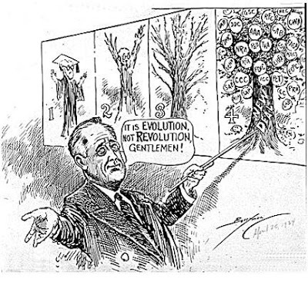
Source: The Evening Star (Washington D.C.) April 26, 1934

Document D

Source: William Lloyd Garrison, Jr., “The Hand of Improvidence,” The Nation, November 14, 1934.

The New Deal, being both a philosophy and a mode of action, began to find expression in diverse forms which were often contradictory. Some assisted and some retarded the recovery of industrial activity... an enormous outpouring of federal money for human relief and immense sums for public works projects started to flow to all points of the compass... Six billion dollars was added to the national debt... a bureaucracy in Washington grew by leaps and bounds... and finally, to lend the picture the heightened academic touch, John Maynard Keynes, of Cambridge, England, ... commenced the play of buying Utopia for cash.
Document E

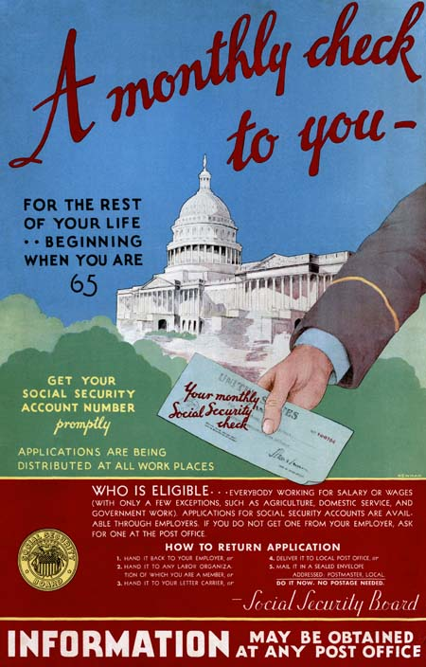

Document F

Source: Charles Evans Hughes, majority opinion, Schechter v. United States, 1935

The question of chief importance relates to the provision of the codes to the hours and wages of those employed... It is plain that these requirements are imposed in order to govern the details of defendants’ management of their local business. The persons employed ... are not employed in interstate commerce. Their wages have no direct relation to interstate commerce...

The authority of the federal government may not be pushed to such an extreme.

Document G

Source: NBC radio broadcast, John L. Lewis, December 13, 1936

It is the refusal of employers to grant such reasonable conditions and to deal with their employees through collective bargaining that lead s to widespread labor unrest. The strikes which have broken out... especially in the automobile industry, are due to such “employee trouble.”

Huge corporations, such as United States Steel and General Motors... have no right to transgress the law which gives to the workers the right of self-organization and collective bargaining.

Document H

Source: “The New Deal in Review” editorial in The New Republic, May 20, 1940

The government as an instrument of democratic action in the future has also been strengthened and renovated. This is not merely a matter of the addition of many new agencies, but of the more efficient organization of the whole executive department - including a planning board under the President which so far has been relatively unimportant but is capable of future development. The Courts, too, have been revivified, partly by legislation, but principally by excelling new appointments, so that we have a Supreme Court which is abreast of the times.

Document I

Source: “The Roosevelt Record,” editorial in The Crisis, November 1940.

To declare that the Roosevelt administration has tried to include the Negro in nearly every phase of its program for the people of the nation is not to ignore the instance where government policies have harmed the race...

At Boulder Dam, for example, the administration continued its shameful policy begun by Hoover of forbidding Negroes to live in Boulder City, the government - built town. And in its own pet project, the TVA, the administration forbade Negroes to live in Norris, another government-built town at Norris Dam.

[The] most important contribution of the Roosevelt administration to the age-old colored line problem in America has been its doctrine that Negroes are a part of the country and must be considered in any program for the country as a whole. The inevitable discriminations notwithstanding, this thought has been driven home in thousands of communities by a thousand specific acts. For the first time in their lives, government has taken on meaning and substance for the Negro masses.

Document J

